[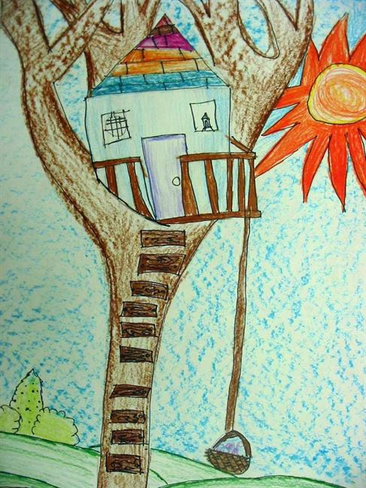](http://kimgolding.weebly.com/uploads/1/1/1/3/11139156/tree-house-9_orig.jpg)[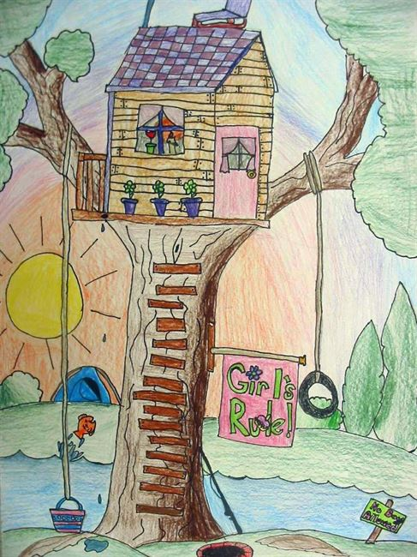](http://kimgolding.weebly.com/uploads/1/1/1/3/11139156/tree-house-1_orig.jpg)[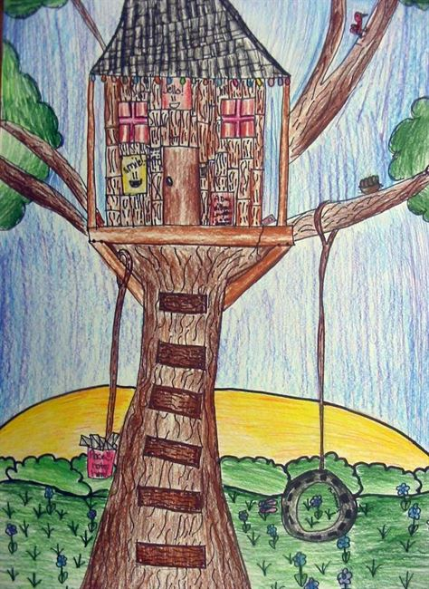](http://kimgolding.weebly.com/uploads/1/1/1/3/11139156/tree-house-2_orig.jpg)[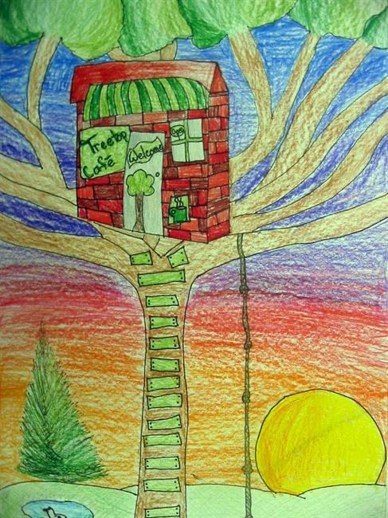](http://kimgolding.weebly.com/uploads/1/1/1/3/11139156/tree-house-3_orig.jpg)[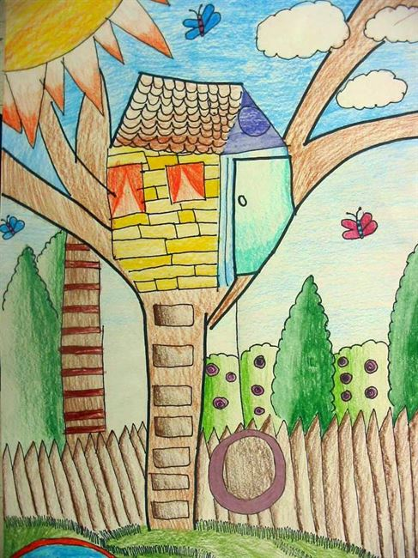](http://kimgolding.weebly.com/uploads/1/1/1/3/11139156/tree-house-4_orig.jpg)[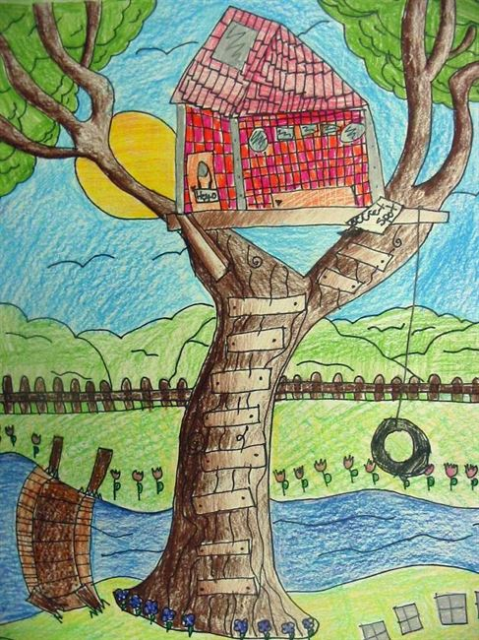](http://kimgolding.weebly.com/uploads/1/1/1/3/11139156/tree-house-5_orig.jpg)

[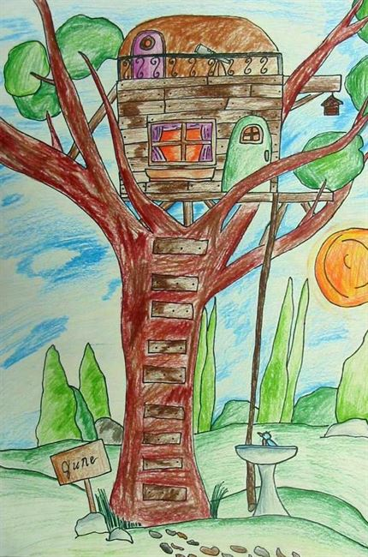](http://kimgolding.weebly.com/uploads/1/1/1/3/11139156/tree-house-6_orig.jpg)[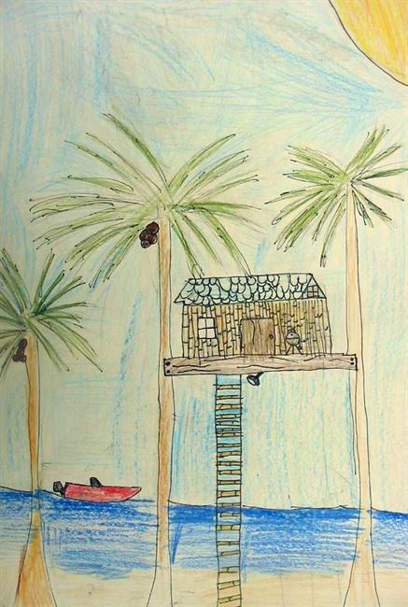](http://kimgolding.weebly.com/uploads/1/1/1/3/11139156/tree-house-7_orig.jpg)[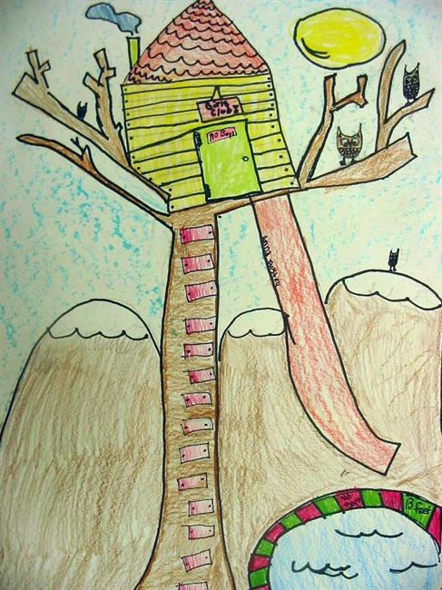](http://kimgolding.weebly.com/uploads/1/1/1/3/11139156/tree-house-8_orig.jpg)